Odoo Dashboard - User Guide

Contents

Purpose 1

Dashboard 1

Saving a View to the Dashboard 1

Change the Dashboard Layout 2

# Purpose

The purpose of this document is to describe the use of the Odoo Dashboard and how to add views to it.

# Dashboard

The Dashboard app allows you to save views in other apps and place them into your ‘Dashboard’, so you have one place to view all your favorite views.

## Saving a View to the Dashboard

To save a view to your dashboard…

1. Open the app with the records you are interested in.
2. Modify the view as you wish to include the proper groups or filters.
3. Once you are happy, click on **Favorites**
4. Select **Add to my Dashboard**

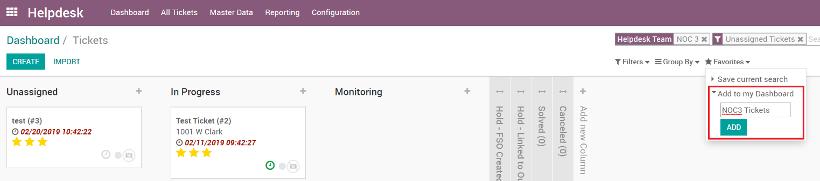

1. Go back to the home screen and open the Dashboard App

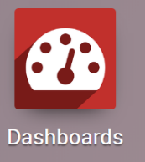

Note: you may need to refresh your browser

1. Now you should see the view on your Dashboard

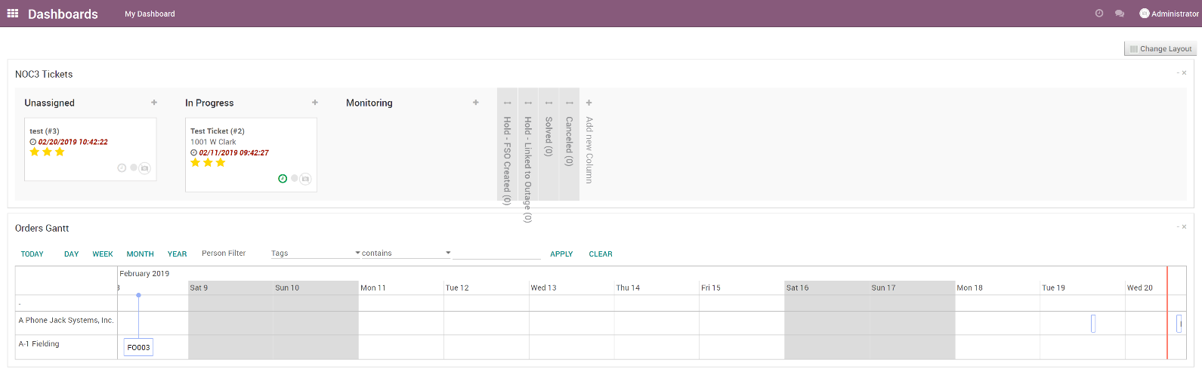

It’s important to know, these views do let you open and change the records, just like if you were in the apps themselves.

## Change the Dashboard Layout

You can modify the way the views are positioned on your dashboard by clicking the **Change Layout** button in the top right. Then choose your preferred layout.

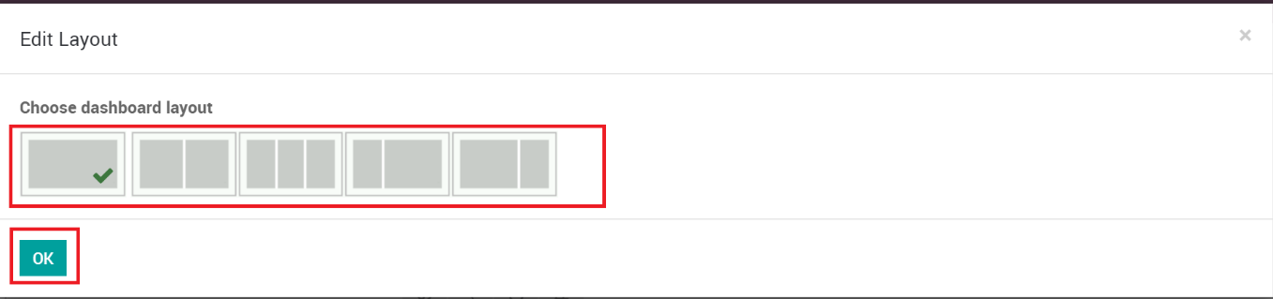

Now you can drag and drop your views to the different areas and re-organize them.

